OUTPUT:

Exercise 1:

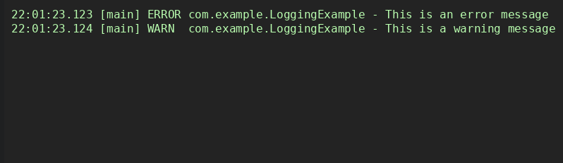

Exercise 2:

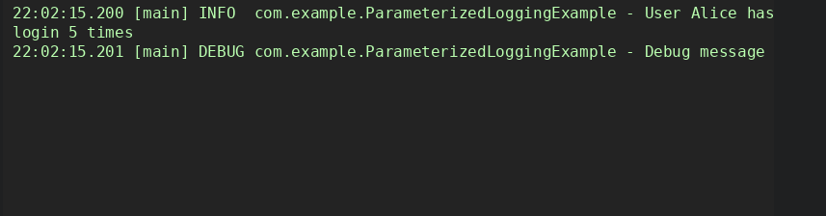

Exercise 3:

